**The Ark Documentation.**

**Data Dictionary module.**

Log in and select your study by clicking the hyperlink corresponding to the name of your study.

Once you have chosen your study we will be able to adjust study details or select modules and functions available in that study (for which you have privileges).

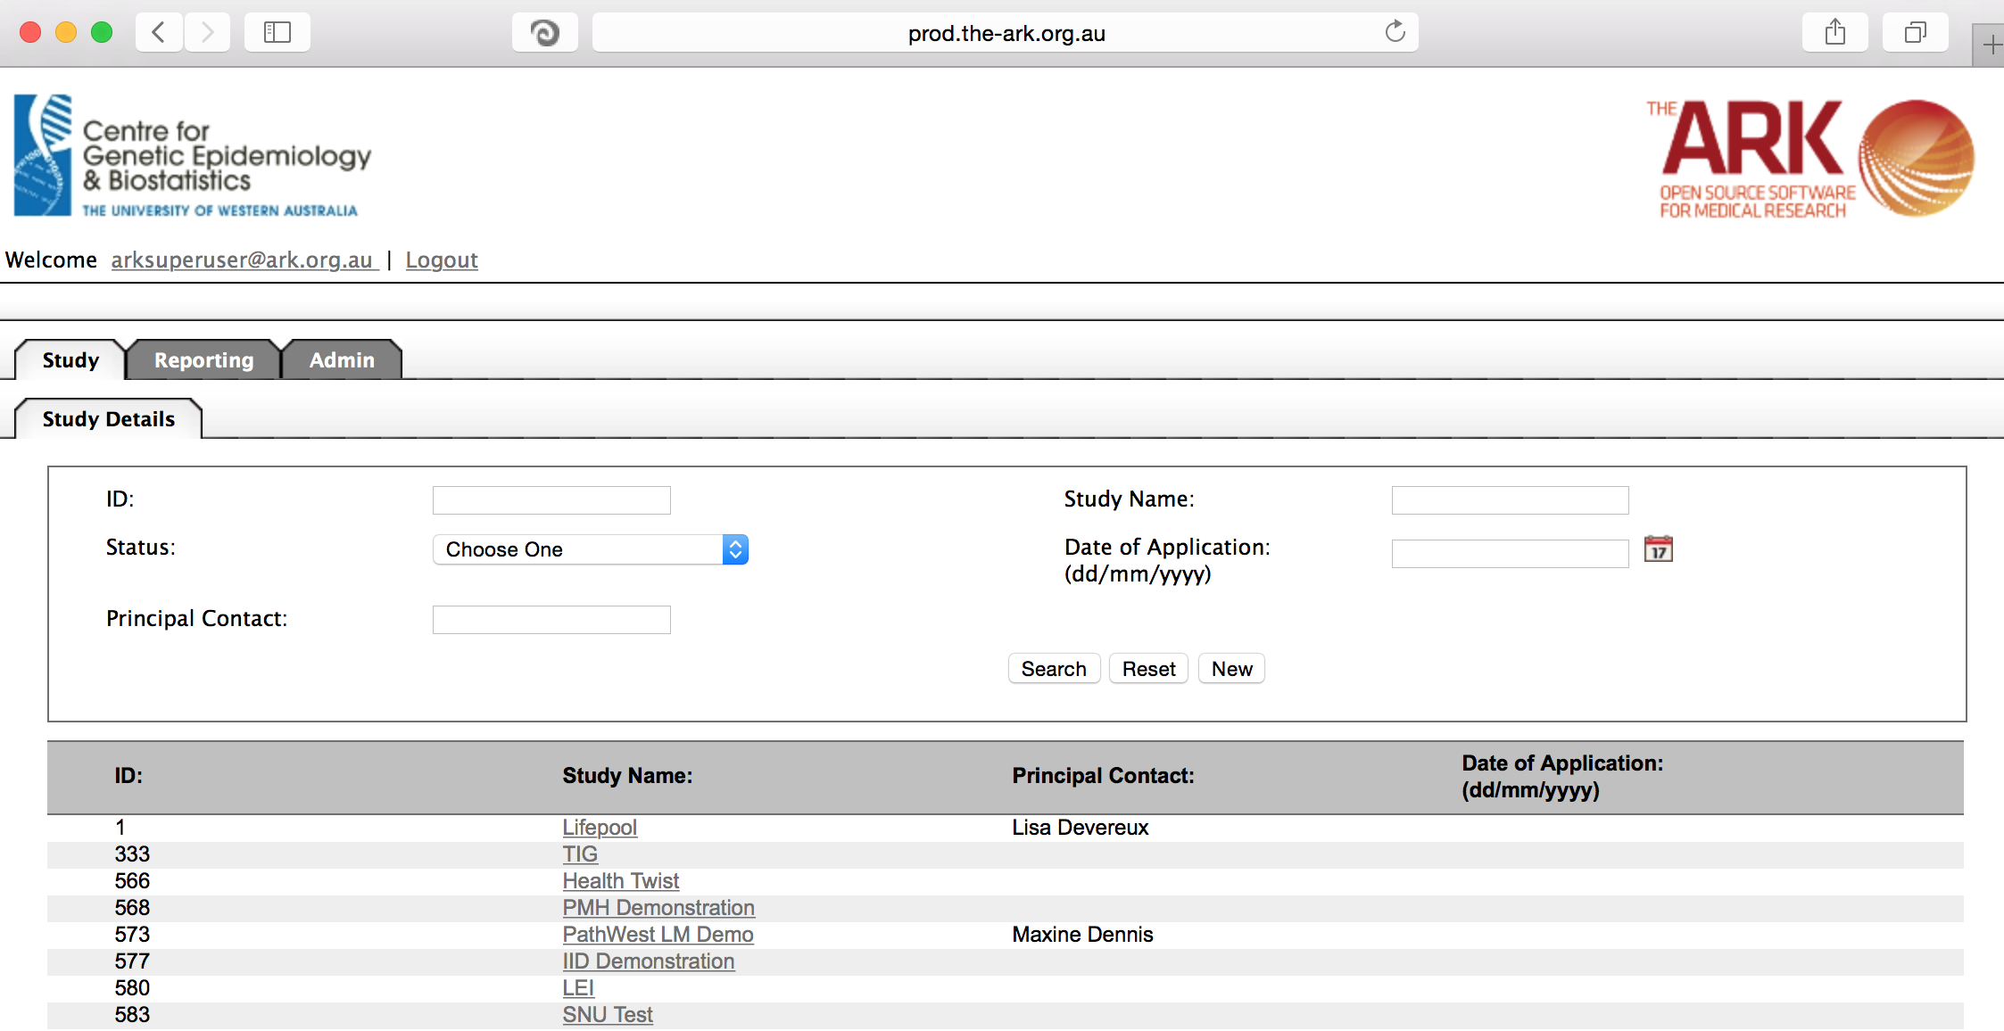

Alternatively if you have a very long list of studies under your management you may use the search pallette/panel at the top of the page. You can search/filter by id, name, principal contact, status of the study or date of application. Once you have added your filtering criteria, click the search button;

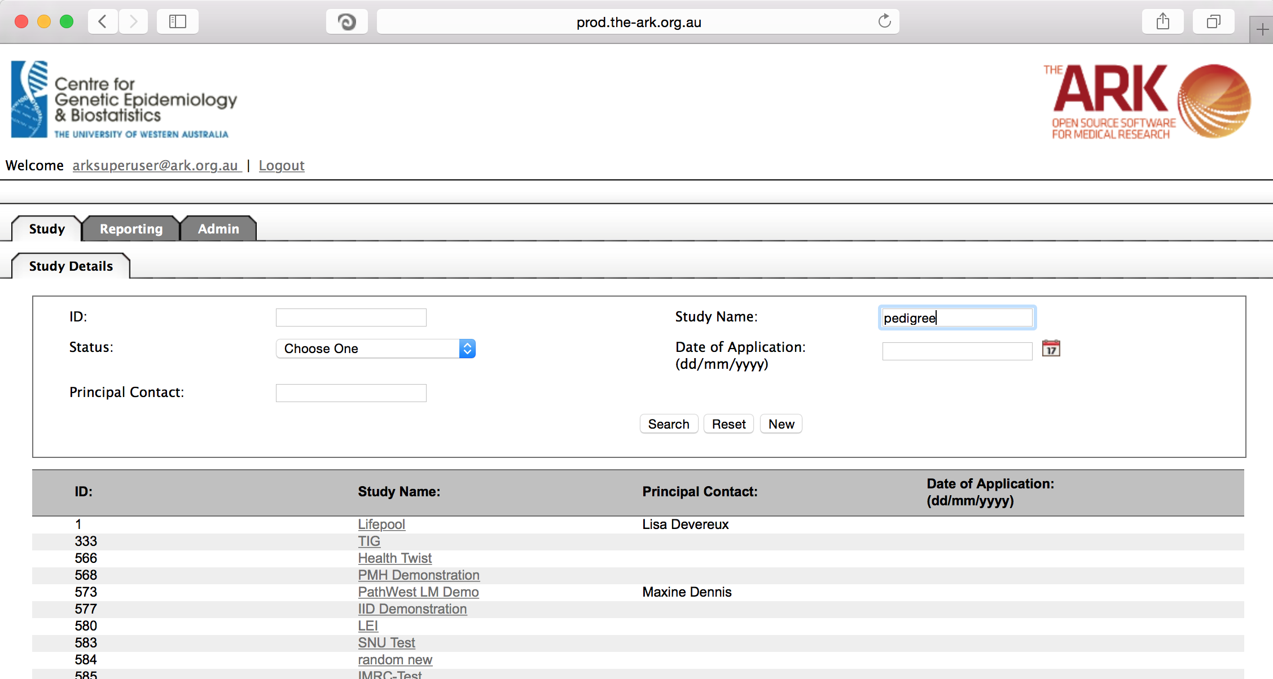

As you can see the filter has helped us find our chosen study and we can click the hyperlinked study name as discussed before;

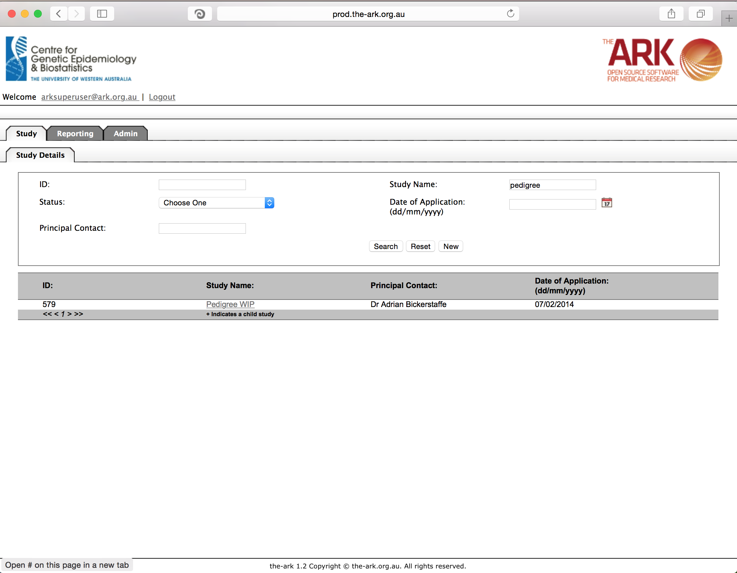

Once you have chosen your study we will be able to adjust study details or select modules and functions available in that study (for which you have privileges). The module we wish to select is Data Sets – then the function “Data Dictionary”.

The data dictionary is the list of longitudinal fields you have to choose from for longitudinal data. Some like to consider this phenotypic data fields, and some have referred to the collections of these fields as datasets or questionnaires. We basically have fields which can be reused and sets of fields which can be reused and re-run over time (ie; longitudinal data).

As you can see, the study below has fields based on systolic and diastolic blood pressure and a few other poorly named fields. These could be used in multiple collections of questions that will be repeated over time.

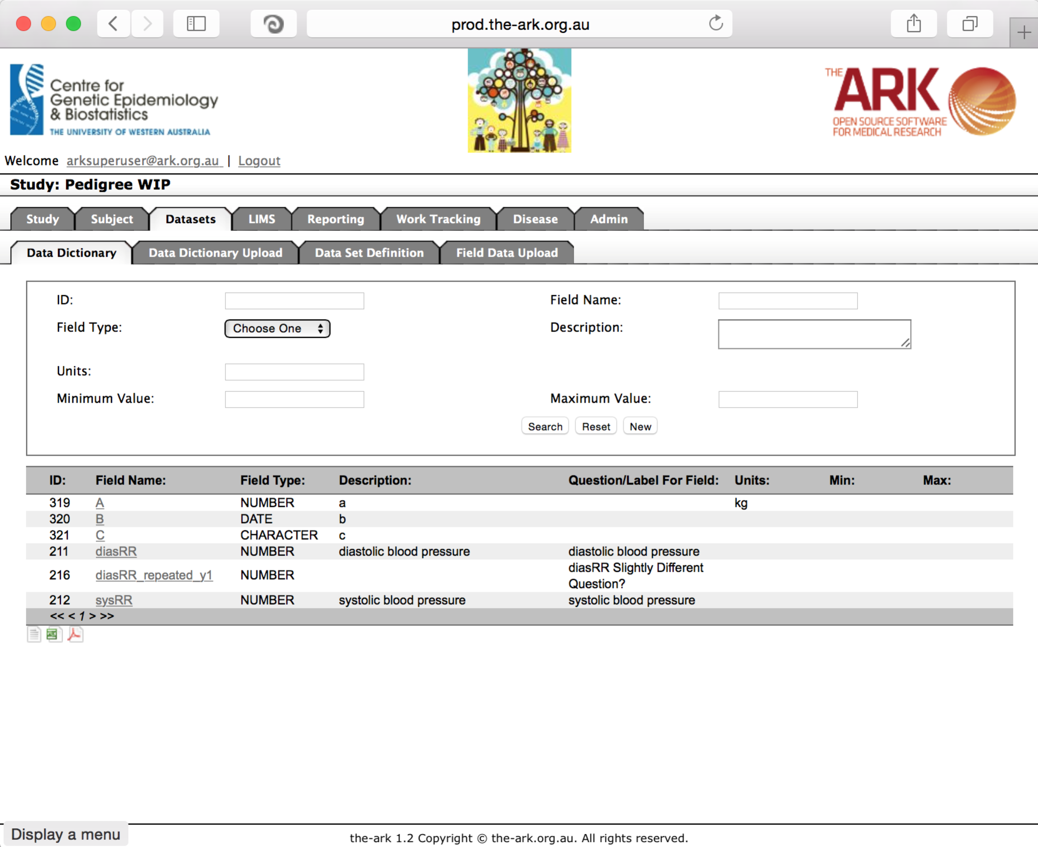

We will now add a 7th field called heart rate.

Start by clicking the new button. The following will appear;

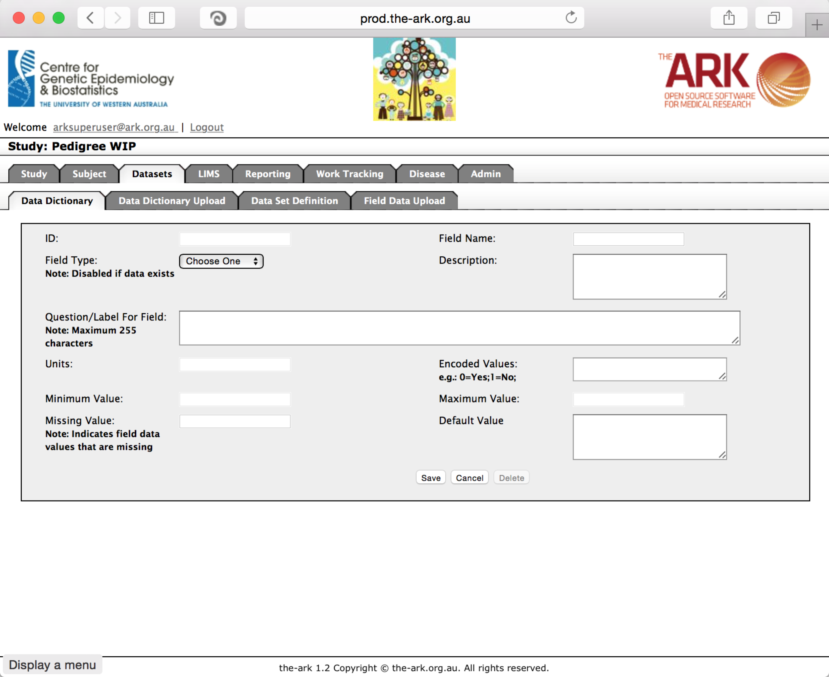Some fields are not so self-explanatory and I will explain those below. The ID field is a system based uneditable field. Field Type can currently only be a number, text, or date. Number fields can have min/max values, and these limits will be strictly enforced on upload of data. A default value will be filled in if empty values are uploaded on a data set upload.

One field that confused some people is the encoded value field. This is described further in the custom field uploader documents. But basically, the idea is (for convenience or to enable data migrations/uploads from another system) you can upload shorthand values like 0 for no, 1 for yes by setting up encoded values as follows “0=no;1=yes;” (minus the quotes).

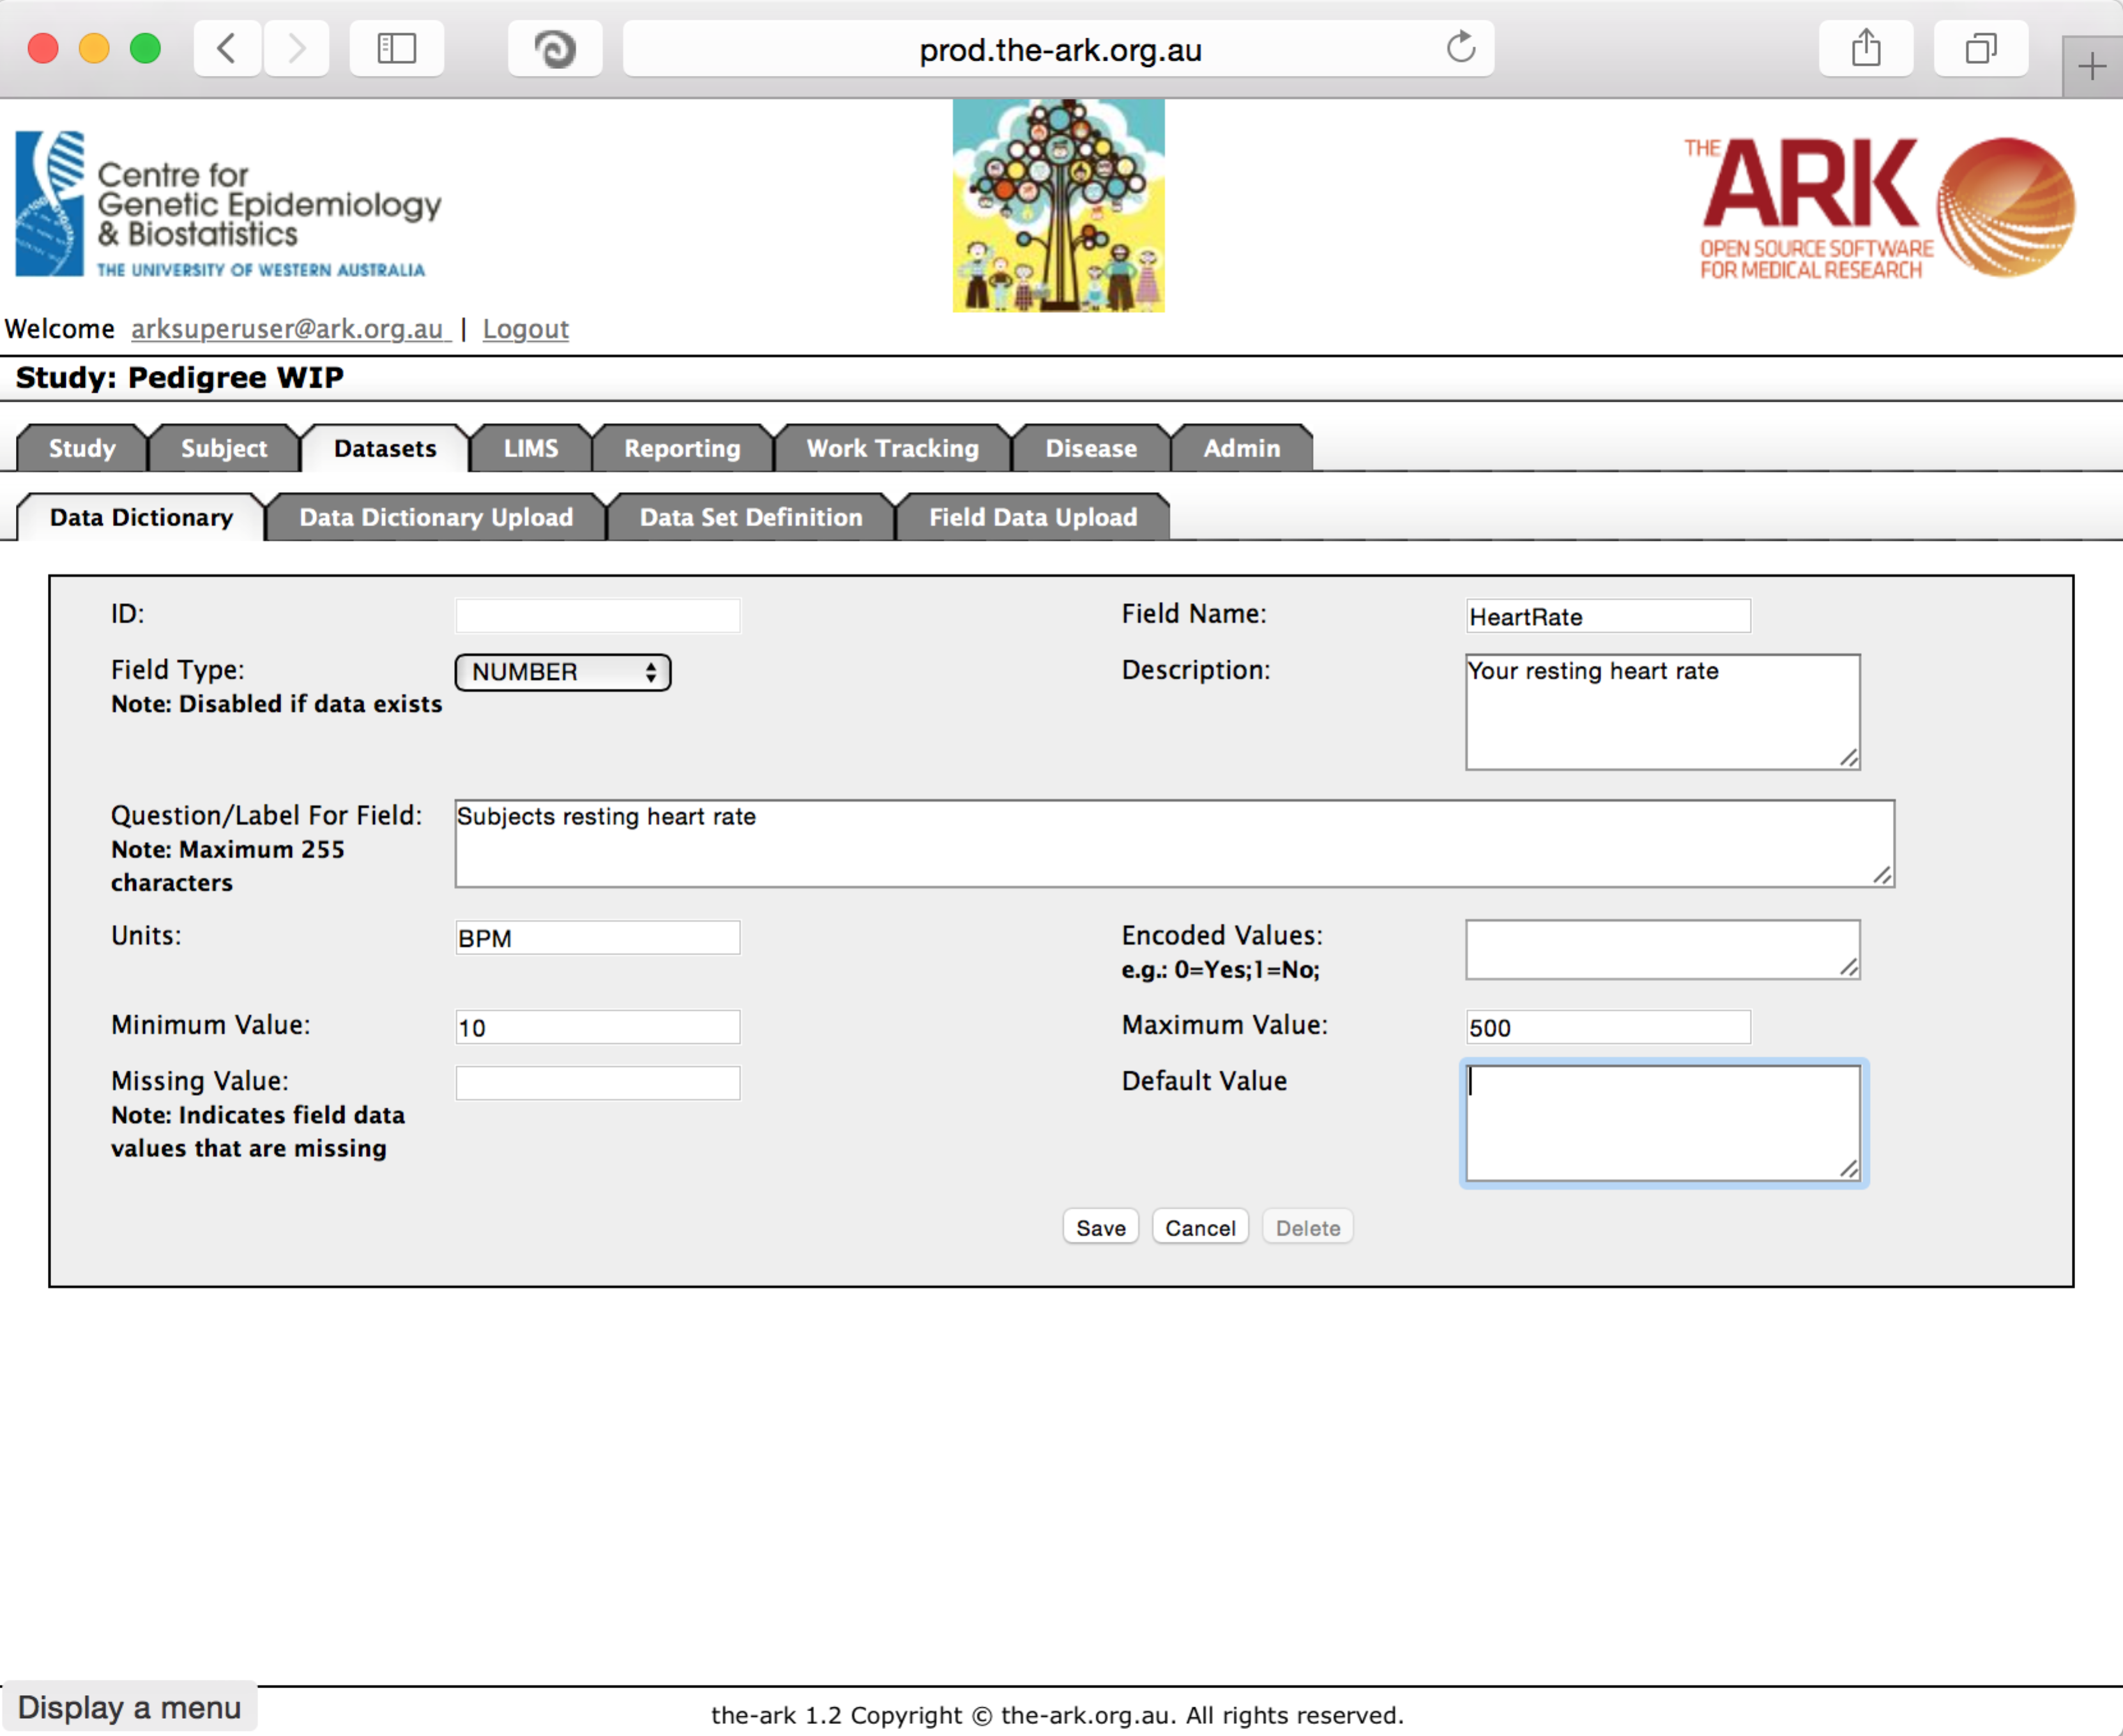

Then click save;

If you have no issues and it has correctly saved, the you will have a green message at the top of the page telling you so. If there were any issues (rare on this page), a message will show up in red describing what you have done wrong.

